**History Page Tests**

**Introduction**

During the implementation stage, various testing was conducted to ensure code had no bugs and that it meets the functionality intended. Examples of testing that was conducted in this feature include, unit testing in visual studio, local tests through Fiddler and test cases were made.

**Unit Testing**

Unit testing was conducted to endpoints in the API to check for any functionality issues. Examples are shown below:

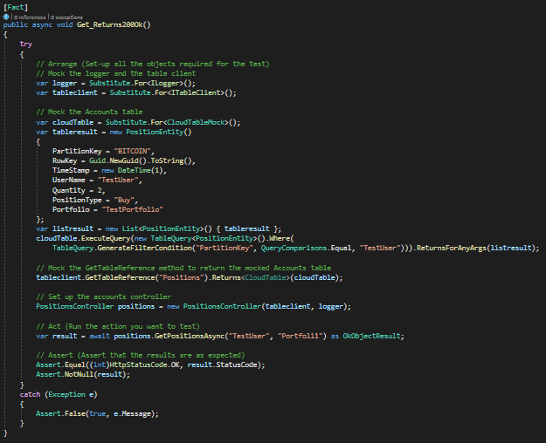GET Endpoint Unit Test:

The functionality of this get end point is to get all transactions that is associated to a username in order to return them in the transactions table in the main page. This unit test checks if this endpoint meets its functionality.

**Local Tests**

Local tests were conducted through fiddler and these consist of testing the endpoint in the API locally to check for bugs before pushing it to Azure.

GET Endpoint Local Test:

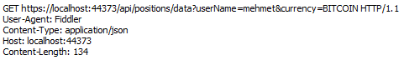

This tests if the get endpoint returns 200 status response without any bugs when trying to get data from azure storage table.

Below is an example showing the endpoint returned a 200 status code indicating the request succeeded.

**Tests Cases**

|  |  |  |  |  |
| --- | --- | --- | --- | --- |
| Test Cases | Description | Expected Result | Actual Result | Status |
| 1 | Initiate buy option with amount | Buy option updates portfolio balance and history table | Buy option updates portfolio balance and history table | PASS |
| 2 | Initiate sell option with amount | Sell option updates portfolio balance and history table | Sell option updates portfolio balance and history table | PASS |
| 3 | Member navigates to history page | Member should be able to view every transaction made by them in history table | Member is able to view every transaction made by them in history table | PASS |